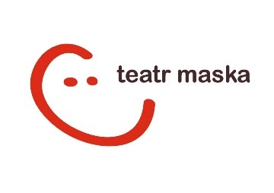
12th International Festival of Theatres of Animated Forms MASKARADA [Masquerade]
Festival theme: gośćINNOŚĆ [Host OTHERNESS]
Rzeszów, 14th-18th May 2022

APPLICATION FORM _ competition

- THEATRE.

Theatre Name:
Website:

Mailing address:
Person responsible for the team's participation in the festival | Name and surname: | Mobile phone.: | E-mail:
Person responsible for technical issues | Name and surname: | Mobile phone.: | E-mail:

- SUBMITTED PERFORMANCE.

Title of the performance:

Link to video recording of the whole performance:
Creators | Author:
 | Director:
 | Set designer:
 | Composer:
 | Choreographer:
 | Others:
Cast:
Date of premiere: | Age of the audience:
Duration of the performance: | Break:  Yes / No | Off-stream performance:  Yes / No
A brief statement on how the performance fits into the idea of the Festival

- TECHNICAL REQUIREMENTS.

Installation time with setting lights: | Disassembly time: | Time needed for the rehersal :
Stage dimensions

width: | height: |  | depth:
Lights:

Sound:

Other:

Max. number of spectators per 1 performance:

Exclusions of seats in the audience:

- OTHER.

Honorarium for the performance:

Transport: | Parking needed: Yes / No  If yes, please specify the type and number of cars:
Number of people in the team:

Number of vegetarians:
Number of single rooms needed: |  | Number of double rooms needed:
Other needs, requests, comments:

Attachments required:
• information about the performance (promotional materials, description, reviews, etc.) and about the theater,
• a minimum of 5 photographs in good print quality (signed with the name of the author of the photo)
• detailed technical rider,
• rooming list.

Date and signature:

The completed Application Form (in an open text file and a scan with a signature) together with attachments should be sent by January 31, 2022 to the following address: koordynator@teatrmaska.pl

Sending the completed Application Form is an expression of acceptance of the Regulations and conditions of participation in the Festival.

